**YouTube tutorial 80 – Writing to files**

**2nd class – createfile.java:**

**import** java.io.*;

**import** java.lang.*;

**import** java.util.*;

**public** **class** createfile {

**private** Formatter x;

**public** **void** OpenFile(){

**try**{

x=**new** Formatter("chinese.txt");

}

**catch**(Exception e){

System.*out*.println("You have an error");

}

}

**public** **void** AddRecords(){

x.format("%s%s%s", "20", "bucky", "roberts");

}

**public** **void** CloseFile(){

x.close();

}

}

**1st class – apples.java:**

**class** apples {

**public** **static** **void** main(String args[]) {

createfile g = **new** createfile();

g.OpenFile();

g.AddRecords();

g.CloseFile();

}

}

Classes should never be named in lower case letters(or so the comments said).

The result was as follows:

(chinese.txt file created)

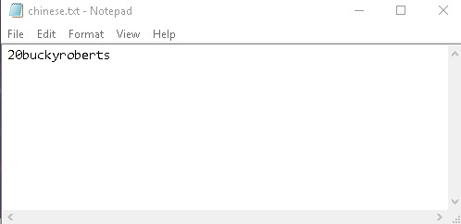

**YouTube tutorial 81 – Reading from files**

**2nd class – Readfile.java:**

**import** java.io.*;

**import** java.util.*;

**public** **class** Readfile {

**private** Scanner x;

**public** **void** OpenFile(){

**try**{

x=**new** Scanner(**new** File("C:\\Users\\Dell\\Desktop\\Java workspace\\Test\\src\\chinese.txt"));

}

**catch**(Exception e){

System.*out*.println("Could not find the file");

}

}

**public** **void** ReadMethod(){

**while**(x.hasNext()){

String a = x.next();

String b = x.next();

String c = x.next();

System.*out*.printf("%s %s %s\n", a, b, c);

}

}

**public** **void** CloseFile(){

x.close();

}

}

**1st class – apples.java:**

**class** apples {

**public** **static** **void** main(String args[]) {

Readfile r = **new** Readfile();

r.OpenFile();

r.ReadMethod();

r.CloseFile();

}

}

The result is as follows:

20 bucky roberts

60 joe doe

50 mike ike

49 sis prise